And

[insert name of school]

Course Booklet

Certificate II in Information Technology (Applications) ICA 20101

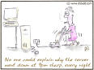

Student: _________________________

© National Corporate Training
This work is copyright, but permission is given to trainers and teachers to make copies by photocopying or other duplicating processes for use within their own training organisation or in a workplace where the training is being conducted. This permission does not extend to the making of copies for use outside the immediate training environment for which they are made, nor the making of copies for hire or resale to third parties.

REGISTERED TRAINING ORGANISATION DETAILS

Name of Training Provider: National Corporate Training National Provider Code 50918
Contact Person: Bronwyn Blencowe
Address: 19 Crivelli Parkway Ashby 6065
Phone/Fax: (08)9404-5959
Email: b.blencowe@nct.net.au

Contents

Section One: Background Information 1
Introduction 1
What is Evidence? 1
What do I have to do for my assessment? 1
How does your teacher assess you? 1
What is this book for? 1
Where does training take place? 2
Special requirements 2
Appeals and grievance processes 2
Deadlines 2
Instructions 3
Section 2: Course Information 4
Section 3: Tasks 8
Assignment Cover Sheet 10
Appendix 1 27

Section One: Background Information

Introduction
This resource has been produced for students to use as part of their Vet program at School in Certificate II in information Technology (Applications) ICA 20101 integrated into Business Information Technology Year 11 and/or 12 curriculum council subject. This subject allocates 120 nominal hours to this program each year.

What is Evidence?
Evidence is the term used to describe the information that your Teacher uses to ensure that you have gained the skills and knowledge in each topic. The evidence that you may provide can take many forms, and suggestions have been provided in the form of the tasks, activities and observation sheets provided in this booklet. It is the responsibility of the student to ensure all work is retained as evidence to enable the teacher to verify that all tasks have been completed. Therefore care should be taken with the security of all personal work. This is also important as examples of student work (written and practical) will be needed for future moderation.

What do I have to do for my assessment?
1. Complete all assigned tasks set by your teacher
2. Collect sufficient evidence for your teacher to assess you (the evidence required is listed next to each competency in this record book).
3. Ask your teacher to complete the observation sheets required at your functions
4. Complete all written work in this booklet and hand to your teacher for marking.
5. Collect all evidence and place into a portfolio (see below for guidelines on your portfolio).
6. Check with your teacher that they have signed your record book and checked your evidence.

How does your teacher assess you?
Your teacher will assess you against each of the units of competency in this Certificate whilst completing your curriculum council subjects. To be sure that you can effectively operate in the Information Technology industry, you need to be able to show that you have the skills, knowledge and attitudes required for your job role. You may be required to complete additional activities as well. These will be used in your assessment to determine your competency. Assessment is a process that will require you to provide evidence that you have achieved the skills, knowledge and attitudes required in the units of competency.

What is this book for?
This Student Record Book is to record the achievement of units of competency which make up your course. This book is a personal record and is used to record and monitor your progress towards achievement of the competency standards required for this qualification.

This record book also has the following functions:

- It is a permanent record of the competencies you have achieved.
- It acts as a guide to record the competencies you have still to achieve.
- It forms the required record for certification of nationally recognised training for this area
- This book may be used when seeking promotion, additional training programs, future employment or applying for Recognition of Current Competencies (RCC).
- This record shows what training has been done and where you might need additional training.

Make sure that the Record Book:
- Is kept in good condition.
- Is kept in a safe place.
- Is made available to your employer, off the job trainer, on the job coach and Teacher s when required.
- Is kept up to date.

Where does training take place?
You complete all training at school, during SWL, and during activities that your teacher organizes for you. This is called a VET-in-Schools program. This program is auspiced or managed by a private (non government) Registered Training Organisation (RTO) called National Corporate Training so you can be awarded the Certificate or Statement of Attainment upon completion of your training.

Appeals and grievance processes
If you are not satisfied with your result or you have a grievance you may appeal to National Corporate Training for reassessment.

Deadlines
All deadlines are prescribed against each task and these must be met to meet competency.

Cheating, Collusion and Plagiarism,
Plagiarism will NOT be tolerated. It is an offence under the copyright act. Any student who copies or allows another student to copy work will attract a rating of NYC. It should be notes that assignments, design briefs and any additional written work MUST be in the students’ own words. The copying of a complete piece of published work (book, magazine, article or downloaded from a computer package or program including the Internet) will not be acceptable and will result in an NYC being awarded. Any quote or extract will need to be acknowledged in the bibliography.

Students commencing a course late
Students cannot be given credit for work not completed in the course except that:
- Students will be given the opportunity to complete missed assessment work
- Opportunities for recognition of current competencies will be provided to the students
- Students will be required to complete tasks already undertaken by the class

Student Responsibilities
It is YOUR responsibility to:
- Complete all assessment tasks by the due date
- Complete all assessment tasks in the assessment booklet
- Initiate contact with the teacher concerning absence from class, missed assignments, extensions and other assessment issues
- To comply with the Schools Assessment Policy and all other School policies regarding attendance and behaviour
- To work safely in all areas and abide by the Safety Policy as outlined in this document. Occupational Safety and Health practices and procedures form a considerable proportion of a number of the course outcomes and is a legislative responsibility for all teachers, staff AND STUDENTS under the Occupational Health, Safety and Welfare Act 1984. All safety equipment is provided for student protection. It is the responsibility of the students to ensure that safety equipment is looked after and any damage that may occur is reported immediately. If students wish to use their own safety equipment they must ensure that the equipment meets the necessary Australian Standards.
- To be responsible for their personal progress as the course is self paced. Students will be expected to consult with their teacher on a regular basis if they are to derive the greatest benefit and appropriate individual guidance. With the limitation of available equipment students need to be prepared to work as a team.

Reporting
Students will be kept informed of their progress in the subject. If students are not achieving their potential, not completing tasks, parents/guardians will be informed of the identified risk to the student.

PORTFOLIO REQUIREMENTS

The portfolio submitted must be of a very high standard of presentation. As a minimum you should have the following:

a. Cover Page
Include subject title, student name, teacher’s name, date of submission, Task or assignment number, Cover page with picture or photograph depicting the topic.
b. Contents Page which identifies specific Assignments
c. All written work word processed.
d. Include a copy of your making sheet for the teacher.
e. Purchase a display folder for all work to be submitted and this is to be kept in a clean and tidy manner with your name and a cover page included. All work submitted is to be word processed.
5. All work must of a high quality and completed safely.

Instructions
Complete the assignment cover sheet over the page and insert as your Page 1 in your portfolio. You must read this and answer the questions and then sign the sheet. Include also the assessment sheet for XXX for the year in which you are enrolled as well as the Competency sheet above. Store these as Pages 2 and 3 respectively in your Portfolio. Have your teacher sign these when you have completed all assessments.

Section 2: Course Information

Business Information Technology (Year 11) – D231

Rationale
This subject caters for students who wish to develop their skills and knowledge in the use of information technology in a business context using the technology process.
Students will have the opportunity to develop competencies which will equip them with broad educational and industry entry level skills as well as providing them with future links to training and post-secondary studies.

This subject will encompass the use of business software, with an emphasis on the elements and principles of design and an understanding of the processes and procedures in relation to business systems and information. The efficient use of cognitive and sensori-motor skills is an integral aspect of this subject in the areas of document design, production and presentation of business-related information technology products and processes.
In response to design problems, determined predominantly by the teacher in negotiation with the student, students will be expected to develop solutions either individually or cooperatively and in teams.
Students will be encouraged to adopt an enterprising approach to the design process. This will entail the acquisition and development of individual and collaborative planning and teamwork, innovation, initiative, creativity, flexibility and persistence in problem-solving. Through the investigation of design problems students will learn to collect, use and communicate information whilst also developing marketing options for products and services.

Outcomes

Outcome 1: Investigates the impacts of information technology products and processes in the business environment.
Outcome 2: Uses the technology process to solve a range of problems found in the business environment.
Outcome 3: Collects data and uses technology to organise data for the presentation and communication of business information.
Outcome 4: Applies and describes the elements and principles of design in accordance with accepted industry standards.
Outcome 5: Works independently, collaboratively and in teams to achieve individual and shared goals.
Outcome 6: Understands relevant information technology systems and processes used in business.
Outcome 7: Uses appropriate software and equipment relevant to design, production and marketing in a business environment.
Outcome 8: Understands work roles, training opportunities and career pathways within business.
Outcome 9: Employs efficient physical, sensory and cognitive techniques to utilise the features of information technology, and applies good ergonomic practices.
Outcome 10: Applies mathematical concepts and techniques to solve problems inherent in the design and presentation of business products using information technology.
Assessment Sheet

Name:

 |  | Outcome
Task | Task Description | 1 | 2 | 3 | 4 | 5 | 6 | 7 | 8 | 9 | 10
One | Report
Two | Presentation
Three | Individual Assignment
Four | Group Project
Five | Portfolio
Final Outcome Achievement

V | = | Very High Achievement
H | = | High Achievement
S | = | Satisfactory Achievement
ND | = | Satisfactory Achievement not demonstrated
 | = | Outcome not related to this task

RATING PROCEDURE
The final rating achieved for each outcome is determined using the following guide.

V is attained when at least 50% of ratings are at a Very High level, and at least 50% of the remainder are at a High level or better.
H is attained when at least 50% of ratings are at a High level or better, and at least 50% of the remainder are at a Satisfactory level or better.
S is attained when at least 50% of ratings are at a Satisfactory level or better
ND is attained when more than 50% of ratings are at a Not Demonstrated level.
Certificate II in Information Technology (Applications) ICA 201010
Certificate II in Information Technology (Applications) ICA 201010 is a practical course designed to give students the opportunity to experience aspects of IT. This course has links to the IT industry and has vocational relevance. This course is a nationally recognised vocational certificate which meets the entrance requirements for the next level certificate in this area.
Students are required to meet 14 Units of Competency (10 Core and 4 electives) in this Certificate to be eligible for the Certificate. These are outlined below. They describe what a student can do as a result of studying that unit. At least two (2) opportunities will be provided for students in order that they may demonstrate achievement of each outcome. In order to achieve competence and have this recognised by an award or qualification you will need to be assessed by an RTO against the relevant units of competency.

Outcomes
Each unit has its own set of outcomes called elements and performance criteria. These are listed in the Unit Guides Section 4.

Context
Assessment must ensure:
- xxxxxx
- xxxxxx
- xxxxx
Course Outline and Competency Sheet
ICA 20101 Certificate II in Information Technology (Software Applications)
Unit Code | Unit of Competency | Nom Hours
 | Core
ICAITTW002B | Communicate in the workplace | 20
ICAITU128A | Operate a personal computer | 20
ICAITU129A | Operate a word processing application | 40
ICAITU130A | Operate a spreadsheet application | 40
ICAITU131A | Operate a database application | 50
ICAITU132A | Operate a presentation package | 30
ICAITU133A | Send and retrieve information over the internet using browsers and email | 20
ICAITB135A | Create a simple markup language document to specification | 10
ICAITU004C | Apply Occupational health and Safety procedures | 20
ICAITU126B | Use advanced features of computer applications | 30
 | Electives
ICPMM63bA | Access the internet | 20
ICPMM21cA | Capture a digital image | 40
ICPMM65dA | Create Web pages with multimedia | 50
ICAITU012C | Design organisational documents using commercial computing packages | 40
 | Total Hours | 430
Teacher’s Signature and print name:

Dated:

Section 3: Tasks

Instructions for Tasks
Complete the assignment cover sheet over the page and insert as your Page 1 in your portfolio. You must read this and answer the questions and then sign the sheet. Include also the assessment sheet for Catering for the year in which you are enrolled as well as the Competency sheet above. Store these as Pages 2 and 3 respectively in your Portfolio. Have your teacher sign these when you have completed all assessments.

OVERVIEW OF ASSIGNMENTS AND TASKS

Unit of Competency | Task Number | Curriculum Council Outcome | Curriculum Council Task | Description
 | One | 1, 3, 6, 8, 9 | Report | Explanation and illustration of technology impacts, products and processes, presented using computer tools.
 | Two | 3, 4, 6, 7, 10 | Presentation | Presentation by students incorporating use of information technology tools, covering aspects of elements and principles of design, production and marketing.
 | Three | 2, 5, 7, 9 | Individual Assignment | Integrated task using several tools and emphasising the technology process.
 | Four | 2, 3, 5, 7, 8, 9 | Group Project | Group investigation and documentation on work roles, training opportunities and careers.
 | Five | 1, 2, 4, 7, 9, 10 | Portfolio | Students will collect work samples which demonstrate their knowledge, skills, use of software and the technology process.

Refer to your task sheets for more detailed information on the tasks and assignment questions required

Assignment Cover Sheet
Course: Certificate II in Information Technology ICA 20101
Ensure all students complete the cover sheet and answer the questions.
Student’s name:
Teacher’s name:
RTO | National Corporate Training Provide Code 50918
School:
Overall Result: | ❑ CO  NYC
The methods used to gather evidence will be as follows:
- Observation
The candidate will be observed by the assessor engaged in events and functions.
- Verbal questioning
The candidate is required to provide answers to the questions presented in this checklist. The questions are used by the assessor in order to probe the dimensions of competency and the candidate’s underpinning knowledge.
- Is the candidate aware of the purpose of the assessment?
- Is the candidate ready for assessment?
- Has the candidate completed the self assessment checklist?
- Has the assessment process been explained, including the procedures for re-assessment?
- Does the candidate understand which evidence is to be collected and how?
- Have the candidate’s rights and the appeal system been fully explained?
- Have you discussed any special needs to be considered during assessment?
I agree to undertake assessment in the knowledge that information gathered will only be used for professional development purposes and can only be accessed by my teacher and the RTO.
Student’s Signature |  | Date:
Assessor/Teacher’s Signature: |  | Date:

Task 1- Outcomes 1,3,6,9 Report - Explanation and illustration of technology impacts, products and processes, presented using computer tools.

Related Unit of Competency | Elements and Performance Criteria | CO or NYC
ICAITU129A | Operate a word processing application
ICAITU132A | Operate a presentation package

Your TASK is to:

Prepare a report based on your investigations into the hardware and software systems used in a business environment and include an outline of the work roles of the individuals in the system as well as a rationale for and costing of the capital investment entailed in setting up the work environment.

You are to include in your report:
- a description of the system components and elements (hardware, software and people) and their uses
- a list giving approximate costings for hardware and software
- comments on the financial implications of the capital investment and resource usage to equip business environments with information technology products
- comments on the relationship of information technology products and processes to productivity and work practices, demonstrating these where applicable
- illustrations of products obtained from advertisements in newspapers, magazines etc
- a reference list giving evidence of research of current technology products and their development
- comments on the skills needed to use the hardware and software in the particular business being investigated
- an explanation of the principles of ergonomics and anthropometrics in the selection of office equipment.

The report must be communicated using information technology tools (eg web page or Power Point) and presented in an acceptable format. A hard copy that is word processed must also be handed in. At least 1000 words is expected in this assignment.

Task 2 – Outcomes 3,4,6,7,10 Presentation - Presentation by students incorporating use of information technology tools, covering aspects of elements and principles of design, production and marketing.

Related Unit of Competency | Elements and Performance Criteria | CO or NYC
ICAITTW002B | Communicate in the workplace
ICAITU132A | Operate a presentation package
ICPMM65dA | Create Web pages with multimedia

Your task is to:

Present a solution in the form of a suitable presentation using PowerPoint or Web Pages to the brief provided by your teacher. This brief should allow students to cover design, production and marketing elements and principles and utilise and select appropriate information technology tools.

You are required to:
- use appropriate hardware, software and processes in their design, production and presentation of the task
- comment on and devise possible marketing materials or strategies
- demonstrate use of estimation and concepts of space and measurement in the design and presentation of materials
- use specific software features to solve mathematical problems inherent in document layout
- select appropriate text and graphic formats in their task presentation
- include a reference list giving evidence of research relevant to the task
- collect and organise examples of the application of design elements and principles from a range of sources including journals, newspapers, brochures, catalogues, and other relevant published materials.

Task 3- Outcomes 2,5,7,9 – Individual Assignment Integrated task using several tools and emphasising the technology process.

Related Unit of Competency | Elements and Performance Criteria | CO or NYC
ICAITU129A | Operate a word processing application
ICAITU128A | Operate a personal computer
ICAITU130A | Operate a spreadsheet application
ICAITU131A | Operate a database application
ICAITU132A | Operate a presentation package
ICAITU133A | Send and retrieve information over the internet using browsers and email
ICAITB135A | Create a simple markup language document to specification
ICAITU004C | Apply Occupational health and Safety procedures
ICAITU126B | Use advanced features of computer applications
ICPMM63bA | Access the internet
ICPMM21cA | Capture a digital image
ICPMM65dA | Create Web pages with multimedia
ICAITU012C | Design organisational documents using commercial computing packages

Your task is to:

Develop a solution to a design brief supplied by the teacher. The solution should allow the student to demonstrate the technology process, the ability to work independently and collaboratively, and provide scope to incorporate the use of a range of software.

You are required to:

- use the technology process to solve the design brief
- provide evidence of their use of the technology process through the keeping of adequate documentation, which should include:
- the design brief, constraints and specifications
- investigation of the problem and existing opportunities
- design sketches and drafts which may include thumbnails, working rough, presentation visuals and proofs (incorporating estimation, concepts of space and measurement)
- a plan that sequences the production events and processes
- evidence of design, ergonomic and anthropometric considerations and application
- design selection, creation and modification
- discussion of marketing principles and strategies
- appraisal
- produce an appropriate document
- use appropriate hardware, software and processes in their design, production and presentation of the task
- comment on and devise appropriate marketing materials or strategies
- select and use specific software features to solve problems inherent in document layout
- include a reference list giving evidence of research relevant to the task
- collect and organise examples of the application of design elements and principles from a range of sources including journals, newspapers, brochures, catalogues, and other relevant published materials
- employ sound ergonomic practices and safe work practice
- demonstrate efficient keyboarding operation.

The competencies achieved will be dependent upon the brief by the teacher.

Task 4 – Outcomes 2,3,5,7,8,9 – Group Project - Group investigation and documentation on work roles, training opportunities and careers.

Related Unit of Competency | Elements and Performance Criteria | CO or NYC
ICAITU129A | Operate a word processing application
ICAITTW002B | Communicate in the workplace
ICAITU128A | Operate a personal computer
ICAITU132A | Operate a presentation package
ICAITU133A | Send and retrieve information over the internet using browsers and email
ICAITB135A | Create a simple markup language document to specification
ICPMM63bA | Access the internet
ICPMM21cA | Capture a digital image
ICPMM65dA | Create Web pages with multimedia
ICAITU012C | Design organisational documents using commercial computing packages

Your Task is to:

In groups of 3 you are to provide a solution In response to a design brief. The design brief will allow students to identify and describe roles, training opportunities and careers by a co-operative investigation and report on a particular area in business.

You are required to:
In groups, to jointly compile an assignment which will provide comprehensive information to peers seeking work in a particular area of business using information technology products and processing skills. It will necessitate:
- the production of documents to elicit and record information
- the appraisal of documents produced by others
- the application of good design in production of business documents
- evidence of their use of the technology process by keeping adequate documentation
- an analysis of the sequencing required to complete the task
- an awareness of the interrelationship between market research, target markets and marketing strategies which may be used
- the establishment of individual and group goals and timelines
- the identification and evaluation of each person’s role and contribution in the group
- clear communication of the entry level standards, opportunities and training demands of information technology within an area of business.

The competencies achieved will be dependent upon the brief by the teacher.

Task 5 – 1,2,4,7,9,10 - Portfolio - Students will collect work samples which demonstrate their knowledge, skills, use of software and the technology process

Related Unit of Competency | Elements and Performance Criteria | CO or NYC
ICAITU129A | Operate a word processing application
ICAITTW002B | Communicate in the workplace
ICAITU128A | Operate a personal computer
ICAITU130A | Operate a spreadsheet application
ICAITU131A | Operate a database application
ICAITU132A | Operate a presentation package
ICAITU133A | Send and retrieve information over the internet using browsers and email
ICAITB135A | Create a simple markup language document to specification
ICAITU004C | Apply Occupational health and Safety procedures
ICAITU126B | Use advanced features of computer applications
ICPMM63bA | Access the internet
ICPMM21cA | Capture a digital image
ICPMM65dA | Create Web pages with multimedia
ICAITU012C | Design organisational documents using commercial computing packages

Your Task is to:

Complete a Portfolio of work samples which demonstrate your knowledge, skills, use of software and the technology process.

You are required to:
Collect documents which typify the problems given and products made in this subject. It should include a range of individual, collaborative and team activities. It will include:
- use of the technology process to solve a range of problems
- the provision of clearly communicated information
- the application of good design in the production of business documents
- an awareness of the interrelationship between market research, target markets and marketing strategies which may be used
- demonstration of sound ergonomic practices, efficient keyboard operation, safe work practice and appropriate use of software features to enhance productivity
- the application of mathematical concepts and techniques when using information technology to make products and solve problems.
- Examples of documents include:
- Spreadsheets
- Databases
- Word documents including letters completed, tables etc
- Documents that have been designed by you
- Samples of emails sent and received
- Address book on Outlook completed
- Web Pages developed
- Power Point Presentations completed
The competencies achieved will be dependent upon the brief by the teacher. Refer to the Unit Guides for details on documents required.

Instructions:

To qualify for the Certificate II in Information Technology (Applications) you must be deemed competent in all Units of Competency by your teacher. This includes the completion of all Curriculum Council tasks in your designated subject and the completion of all questions and activities in this assignment booklet.

Unit Code: | Unit Name:
ICAITTW002B | Communicate in the workplace

1. Scenario
You have been requested to develop a web site for a company. Explain the process you would go through including how to contact clients and process the internal and external requests from the client and your team; how you would determine your client support needs, how you would inform your client of the progress and action you have taken to date. Explain how you would use questioning and active listening techniques when obtaining information and determining client support needs. Explain how you use negotiation skills in relation to other team members when creating an effective service environment.

Unit Code: | Unit Name:
ICAITU004C | Apply Occupational health and Safety procedures

2. Complete the Safetyline Smart Move Certificate – Generic and Business at www.safetyline.wa.gov.au

3. Explain how you would comply with Occupational Health and Safety requirements relating to the use of computing equipment, how you would identify unsafe practices and what action would you take to correct these unsafe practices.

4. Conduct a hazard check of your immediate IT classroom. Document any hazards found and solution to fix these hazards. Write a brief report for your teacher.

5. Research and download from the Internet an occupational Health and Safety document which relates to workstations – include this in your portfolio.

Unit Code: | Unit Name:
ICPMM63Ba | Access the Internet

6. Answer the following questions:
a. What is the internet software on your PC and what is its purpose?
b. Define the following terms ISDN, PPP, TCP/IP, Java, Javascript, HTML, download, WWW
c. Identify and explain the type of Internet connection in use
d. Search for documents on the web and printout at least three and store in your
portfolio ensuring you capture the source on the document.

7. Demonstrate the following by having your teacher check your competency using the following checklist:

Competency | Attempt 1 | Attempt 2
Demonstrate how Internet software can be used off line
Use unarchiving (uncompressing/extracting) software and virus scanner on downloaded files
Browse the WWW to find related sites via links
Retrieve files from an FTP repository
(this can be simulated – see instructions below for bigpond FTP)
Send, download, read and respond to e-mail
Retrieve files attached to incoming e-mail, and send attached files
Access newsgroups relevant to the IT industry
Demonstrate the use of a chat program (eg IRC, ICQ, MSN)
(this can be simulated by students accessing at home and importing screen dumps into word)

Accessing Bigpond FTP repository:

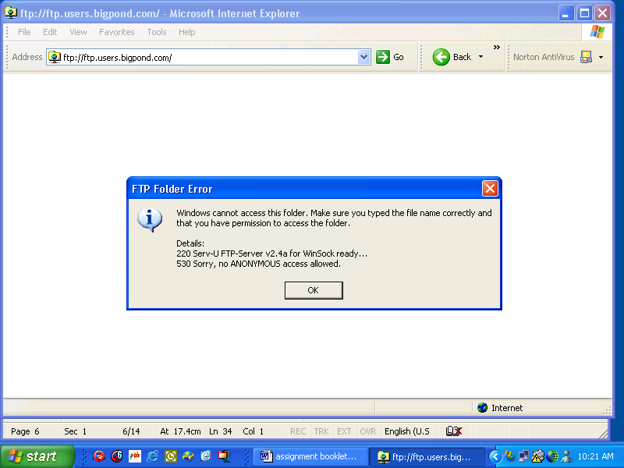

Click OK

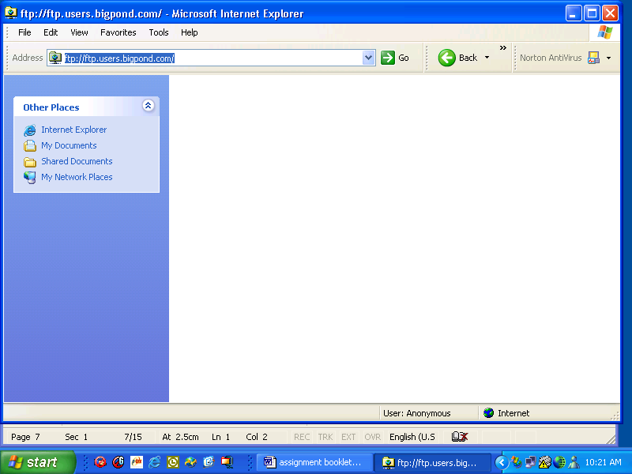

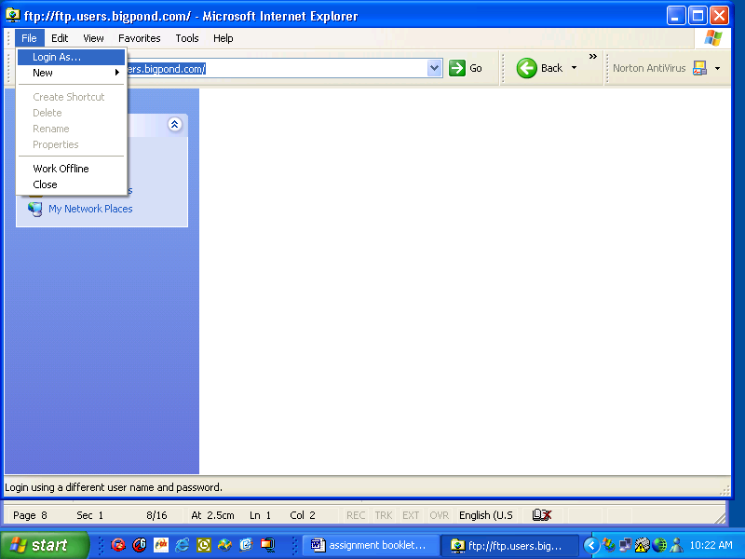

To go any further than this requires a password so I have inserted screen dumps of my FTP repository for my web site so students can see the next step.
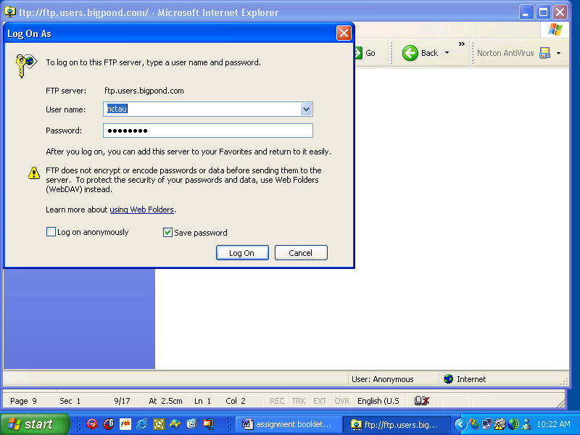

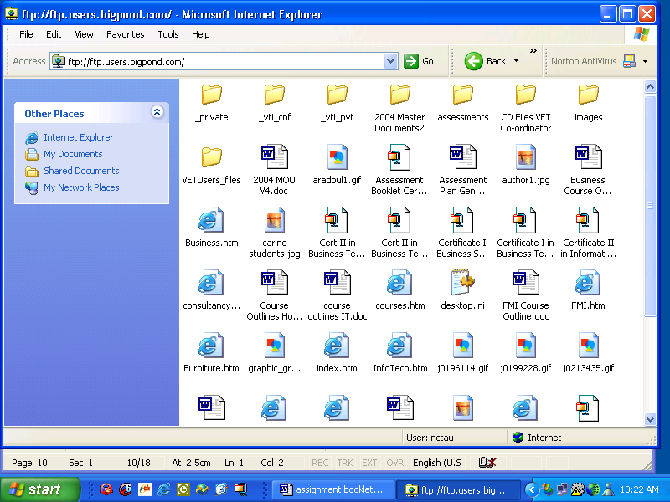

At this point I can now copy and paste files from my hard drive to the web and my web pages stored on my hard drive can be uploaded by copying and pasting them to this site.

Unit Code: | Unit Name:
ICAITU130A | Operate a Spreadsheet Application

Tasks to Complete

Create the following documents:
- Create a folder and call it ICAITU130A and save all documents as files to this folder on your School Drive and in your personal account.
- Use manuals, user documentation and on-line help to overcome problems
- Exit the application without data loss/damage
- Answer the following questions, type up your answers and format the page as directed below.
  - State the purpose and ranges of uses of spreadsheet's functions
  - The page is to be formatted with 2.5cm top and bottom margin; 3.5cm left and right hand margin, the vertical alignment to be at the top, the header and footer to be 1.27cm from the edge and the page to be Landscape. Insert a footer with your name and page number showing “Page 1 of 1”. Do not type this but set it up automatically. Set the line spacing to be 1.5 lines; and a tab set at 3cm at left. Select the font “Trebushet MS Regular” and font size at 12.
  - Check all documents for accuracy, spelling and grammar. Print out the documents as they are currently typed. Print out the spreadsheet using values and again using formulae. Insert all documents into your Portfolio.
- Create a spreadsheet which displays the following information:
  - You are to calculate totals and display figures and formulas on two separate printouts.
  - In the spreadsheet calculate the maximum, minimum, average of a group of cells. Show the formulae for adding a column of numbers from the spreadsheet. Show also the formulae for subtraction, multiplication, division in the spreadsheet.
  - Use absolute and relative cell addresses in calculating a column of figures.
  - Format the spreadsheet to include formatting of text eg font size 12, Times New Roman, Regular Font. All date cells formatted for date, all number cells formatted for numbers. Ensure columns are fixed width. Ensure that you have a footer with your name in it and page number. Insert a header with the name of this Unit of Competency.
  - Put a border around the spreadsheet and print out on the full page in landscape view.
  - Charts using a column, stacked, 3-D column, bar, stacked / multiple bar, line, pie and 3-D pie, exploded pie, scatter / bubble, area charts. Chart features to include data labels, axis title, chart title, legend, gridlines, axes, data tables, colours, patterns, lines, fills, borders. The Chart to represent a comparison of current assets to current liabilities for each of the two quarters shown in the spreadsheet.

ABC Resources Company
Projected Cash Flow
Month: | Cash Bal November | January | February | March | April | May | June | Totals
Income
Credit Sales
John Borgan Pty Ltd |  |  |  | 2500 |  |  | 2500
Henry Jones IXL Pty Ltd |  |  |  |  | 3750
IT traineeships |  |  | 19500 |  |  | 15000 | 10500
Office Admin Traineeships |  |  | 625 | 1250 |  |  | 1875
Retail Traineeships |  |  |  | 625 | 2500 |  | 3125
CAT Program |  | 10025.6 |  | 5639.4 |  |  | 5398.4
Fees from courses |  | 2850 |  | 3000 | 3000 |  | 3000
Tractor and Trains Company |  |  | 1500 |  |  | 1500
Treasury Department |  | 760 |  | 760 |  | 760
Tafetta Trading Company |  | 760 |  | 760 |  | 760
WA Government Fees Received |  | 650 | 650 | 650 | 650 | 650
Brown and Green Pty Ltd |  |  | 7550 |  | 1500
Smith and Weston Pty Ltd |  |  | 45000 |  |  |  | 45000
Cash Sales
Learning Resources |  | 1120
Capital Introduced by BC
Capital Introduced by DA
Loans Received
Input Tax Credits from GST |  | 1900 |  | 1900 |  |  | 1900
Consulting |  |  | 2000 |  | 2000 |  | 2000
Group Training Consulting |  |  | 1000 |  | 1000 |  | 1000
Group Training NAAP |  |  |  | 20000
Private Industry Tenders
Total Receipts
Payments
Advertising & Printing |  | 0 | 2,000 | 0 | 0 | 0 | 1,000
Bank Charges & Interest |  | 100 | 100 | 100 | 100 | 100 | 100
Bonuses for staff
Capital Purchases |  | 3,000 |  | 3,000
Cash Purchases |  | 100 | 100 | 100 | 100 | 100 | 100
GSt Payments |  | 1,900 | 0 | 1,900 | 0 | 0 | 1,900
Heat, Light, & Power |  | 0 | 400 | 0 | 0 | 400 | 0
Cat program |  |  | 4,416
Hospitality |  | 50 | 50 | 50 | 50 | 50 | 50
Insurance |  | 0 | 0 | 1,000 | 0 | 0 | 1,000
Motor Vehicles Costs |  | 1,350 | 1,350 | 1,350 | 1,350 | 1,350 | 1,350
Partners Salaries (See note 4) |  | 5,000 | 5,000 | 5,000 | 5,000 | 5,000 | 5,000
Payments to SubContractors |  | 240 | 13,920 | 5,680 | 5,440 | 5,680 | 5,440
Postage & Packing |  | 50 | 50 | 50 | 50 | 50 | 50
Learning materials |  | 500 | 500 | 500 | 500 | 500 | 500
Rent & Rates |  | 1,330 | 1,330 | 1,330 | 1,330 | 1,330 | 1,330
Repairs & Renewals |  | 400 |  | 400 |  | 400
Sundry Expenses |  | 200 | 200 | 200 | 200 | 200 | 200
Superannuation (12%) |  | 101 | 101 | 101 | 101 | 101 | 101
Telephone |  | 900 | 900 | 900 | 900 | 900 | 900
Wages |  | 844 | 844 | 844 | 844 | 844 | 844
Total Payments
Cashflow Surplus/Deficit (-)
Opening Bank Balance | 2000 | 2000
Closing Bank Balance | 2000

Unit Code: | Unit Name:
ICAITU1280A | Operate a personal computer

13. Printout from your computer the system information. Hint: Click on “Programs, Accessories, System Tools, System Information”.

14. Customise the desktop of your PC using a variety of themes. Print Screen Dump of each to a word File and store in your portfolio. If your school does not allow this then complete this activity at home. Ask your teacher if you are having any difficulty with this Task.

15. Print a screen dump of each of the following tasks and print to a word file. Print out and store in your portfolio.
- Desktop icons are correctly selected, opened and closed
- Desktop windows are opened, resized and closed
- Shortcuts from the desktop
- Basic directory and folder structures
- Listing of Directories/folders with subdirectories/subfolders
- Moving of a Subdirectory between directories/folders
- Directories/folders are renamed
- Directories/folders and subdirectories/folders are accessed via different paths
- The most commonly used types of files in a directory/folder are identified
- Files are created and suitably named
- Groups of files are selected and opened and renamed
- Files are copied or cut and pasted across directories
- Files are copied to disk
- Deleted files are restored
- Software tools are used to locate files eg search function
- Print information – show the printer queue
- Progress of print jobs viewed and deleted
- Default printer is changed for installed list
- Shutdown computer
- All open applications are closed

16. OPERATE A PERSONAL COMPUTER Checklist – Have your Teacher observe you and complete this checklist when you feel you are ready

Description | Student to tick | Teacher’s Initials
Start the computer
Log on as a user
Configure the layout and look of the desktop to personal requirements
Format floppy disks
Help function used to identify how to format disks or change the look of the desktop
Open and close desktop icons
Windows Explorer is opened from the Start Key
Windows Explorer is opened using a short cut method
Windows Explorer is used to access the directories, files and folders
The printer icon is opened to check status of the print job
The recycle bin is opened, emptied and closed
Create a short cut icon on the desktop for word processing, spreadsheet, database, virus scan and bookkeeping software
Word processing, spreadsheet, database, virus scan and bookkeeping software is opened from the desktop shortcut icons
Different software programs are opened from the desktop through right mouse click
Windows are minimized, maximized and closed
The file name extensions for Microsoft Word, Excel and Access are identified
Folders and subfolders are created, named appropriately and maintained using Windows Explorer
Folders and subfolders are created, named appropriately and maintained using Microsoft Word
File and folder sizes are identified (how many megabytes a file is)
Dates when files and folders are created are identified
Files and folders are cut, copied and pasted into different folders and directories using Windows Explorer
Files and folders are cut, copied and pasted into different folders and directories using Microsoft Word
Directories, folders and files are renamed using Windows Explorer
Directories, folders and files are renamed using Microsoft Word
C drive, A drive, E drive and Network drives are accessed using Windows Explorer
C drive, A drive, E drive and Network drives are accessed using My Computer
C drive, A drive, E drive and Network drives are accessed using Microsoft Word
The most commonly used files are stored so they are easy to retrieve
New files are correctly named and stored in the correct folders
Using Windows Explorer select a group of files at the same time
Using Windows Explorer files are opened by both double left mouse click and by right mouse click
Files are copied to A drive
Restore a deleted file from the Recycle Bin
Use the search tool in both Windows Explorer and the Start Key to search for files and folders in A drive, C drive, E drive and network drives
Information from word processing, spreadsheet and database is printed
The progress of print jobs is viewed and deleted where necessary
Change the default printer
All open software programs are saved and closed
Computer is re-started
Computer is shut down
Access the internet and find information on the correct ergonomic angles to use when working at a computer
Print this information off
Display the information next to the computer
Apply these ergonomic principles every day when working at the computer
Using Microsoft Word test your typing speed in words per minute. Hint – one word is classed as 5 characters with spaces. Click on tools – word count after selecting the words you typed in 1 minute. Divide the characters with spaces by 5 to get your speed in words per minute
Perform keyboarding skills to the speed required by the workplace – words per minute
Identify the main features of Microsoft Windows
Identify the main parts of a computer
Identify how much storage a Floppy Disk, hard disk, zip drive and cd rom can hold
Run the virus software to check for viruses and delete them when found
Comprehend basic workplace documents
Interpret user manuals for computers, printers or scanners
Communication skills to seek advice, use questions to clarify instructions, follow instructions and receive feedback
Solve simple computer problems in the workplace
Communicate and relate to people from a range of social, cultural and ethnic backgrounds

17. Outline general security, viruses, privacy legislation, and copyright
18. State the main parts of a computer and various hardware components
19. Explain what a computer system is?
20. Explain how you erase and format a disk.
21. State the main types of software
22. State the storage devices and basic categories of memory
23. State the main types of computers

24. Explain how you create shortcuts from the desktop

25. Explain how the basic computer performance in relation to the information provided in advertisements for computers works

26.
Name the parts of the desktop in the picture below and the function of each.



Unit Code: | Unit Name:
ICAITU129A | Operate a word processing application

27. Prepare and type up the following documents ensuring that accuracy is 100% and all documents are prepared to industry standards.

- Your boss wants to send a letter to a client asking him to pay his account of $300 which has been outstanding for over 3 months. You know that there is a problem with his last order and your boss wants you to “sort it out”. Draft a letter to ensure it covers all points mentioned above. Your boss’ name is Henry Landsdale, your company is called Wanneroo Wholesale Nurseries and your address is 354 Wanneroo Road, Wanneroo 6065. Your boss is the Managing Director. Your client is Mr John Greentrees from 35 Trichet Road, Wanneroo. His company name is Benton Greentrees.
- Draft a memo to the accounts payable officer Jill Jones and advise her of the action you have taken in (a) above.
- Draft a fax to the local lunch bar “Munchies” fax number 96547865 asking them to quote a price to cater for a light lunch for 30 people this Friday 15th August 2003 for your boss.
- Prepare a mail merge to 10 clients requesting that their monthly orders be submitted early in June due to the end of the financial year occurring. Make up details as required for the following fields:

Title of person:
Name of person:
Address of Company:
Name of Company:

Type of order: eg (weekly, fortnightly, monthly)

Include all the above as fields in your mail merge
Include also the date and signature block for your boss
e. Include as a field the person’s first name eg Dear …Bill

Unit Code: | Unit Name:
ICAITU131A | Operate a database application

28. Create a database of at least two tables that are linked of all the students in your class for your teacher. Details are to include everyone’s name, DOB, gender, subject name in one table. In the other table fields are to include a hobby for each person and suburb of where they live. Create a simple form to key in all the data and then produce a report for your teacher that displays all of the above information.

29. Produce a printout of all reports and forms from a two table minimum database you have created
30. Draw a basic database design

Unit Code: | Unit Name:
ICAITU132A | Operate a presentation package
31. List the different types of presentations in PowerPoint
32. Create a presentation using Power Point that displays the following information for selling a product that you have created in your spare time. Create the concepts and then create the presentation to sell your product to potential clients. Include the following:

Objective of the presentation, Why the customer should buy your product, How does your product meet their needs, List the products and features, and how each addresses a specific need or solves a specific problem, Cost Analysis of your product, Point out financial benefits to the customer, Compare cost-benefits between you and your competitors, The Strengths and Key Benefits of your product, Specify the actions required of your audience

You are to include animation, page numbering, consistent background, colour, charts, pictures and sound in your presentation. Navigation should also be included as should page transition.

33. Printout of a Presentation using Power Point and an electronic copy

Unit Code: | Unit Name:
ICAITU133A | Send and retrieve information over the internet using browsers and email

34. Printout samples of the following:
- Address Book created in Email program
- Copy of an email sent and received with auto signature block
- Printout from an internet site
- Printout of bookmarks folder (Favourites)
- Printout of a search conducted through Google and Alta Vista
- Printout of an email with a reply and an attachment
35. What are your organisation’s guidelines on internet and email usage, web etiquette?
36. List some different types of search engines (meta etc)
37. Describe net etiquette?
38. What is the maximum size of an email for ISP’s?

Unit Code: | Unit Name:
ICAITB135A | Create a simple markup language document to specification

39. Go to the Site at Charles Darwin University and complete the tasks listed on this site for this unit. http://informatics.cdu.edu.au/staff/klesch/icaitb135a/
Print out all practicals and store in electronic format and include in this portfolio.

Unit Code: | Unit Name:
ICAITU126A | Use advanced features of computer applications

40. Printout of an organisational chart
41. Provide an electronic copy and hard copy as appropriate of any documents you have created that displays the following:
a. a macro and a template you have created in word
b. An add in menu template in word
c. Comment boxes in excel
d. Printout of the properties box showing updated information entered by you
e. Linked spreadsheets in excel
f. Lookup functions used in excel
g. Match functions used in excel
h. Data imported from one software package into another and reproduced into word
i. Hyperlinked documents
j. Use of bookmarks
k. Use of a document map
l. Use of autotext, fields, text boxes, objects, index or contents tables
m. Footers, headers, tables, columns
n. Use of date and time functions, formula functions in tables, symbols, pictures, backgrounds, themes
o. customising toolbar
p. autocorrect functions
q. merging and splitting cells in tables
r. Formula auditing in Excel
s. Create a macro and a query in Access
t. Import data from Excel into Access
u. Shortcuts and features created for increased productivity

Unit Code: | Unit Name:
ICPMM21cA | Capture a digital image

- What are the main considerations when operating a digital camera?
- Choose a software package for uploading and/or manipulating your images and explain why have you chosen this digital image software?
- What are thee capabilities of other software packages? How are digital collages and montages created?
- What are the major considerations when creating digital montages and collages?
- Describe THREE ways of enhancing digital photographs.
- What manuals, safety documentation, etc are relevant to this task and where are they kept?
- What information is included in these documents?
- What other sources of information are available?
- Assess the capacity of, and operate, a digital camera to upload and process THREE digital images using industry hardware and software to deliver a designated quality of image outcome
- Printout the three digital images and provide a soft copy
- Explain what “Pixel resolution of the camera” means.
- Explain why you need to match the pixel resolution to the required quality and resolution of outcome?
- Explain what “RAM capacity of the camera” means and why do you need to check it against the number of images required to be captured?
- Explain the terms “Shutter speed, focal lengths and camera feature modes (flash, scrollage, icon menu, close-up, wide angle and telephoto capacity” and explain why you need to assess these against the quality and use of photographic image required?
- How do you handle and store Lithium batteries?
- Explain how you upload the The IBM-PC or Macintosh card interface / disk onto the relevant computer and the image saved on hard disk?
- How do you create and store photographic image files on the computer in accordance with software procedures?
- How do you enhance, crop and alter electronically any photographic images?
- Explain how you would checked for fitness of purpose to comply with the brief specifications including relevant delivery mode eg print, CD ROM of any photographic images you have taken?

Unit Code: | Unit Name:
ICPMM65dA | Create Web pages with multimedia
- Outline the makeup and structure of web addresses
- State the modem speed, traffic loads in relation to times of accessing the internet on your computer system?
- List some different types of messages that occur (error messages, updates, plug ins etc)
- Identify the tools and parameters of web page design
- Describe the use of HTML or XML on and off the Internet
- Outline the differences between page layout languages versus document content description
- Choose the file type for images and other data to suit the intended viewing environment
- Name the HTML or XML specifications and extension types and a suitable XML or HTML or DTD is chosen f or the current task
- Identify types of web authoring software and select in accordance with type of authoring task and workplace procedures
- Produce a minimum of three web pages using images, sound and other referenced files . Use web-authoring, conversion or test editing software to prepare pages incorporating text with images and video, sound, scripts or programming according to design brief
- Save completed XML, HTML pages to hard disk with appropriate names
- Check raw XML or HTML for obvious redundancies and omissions and enhance is necessary with recent extensions, ALT tags etc
- Validate and prepare for distribution all pages for suitable syntax parsing and rules checking software and correct as necessary
- Upload pages to server for access
- Check internal and external links for functionality in their final location
- HTML is corrected in response to validation reports until clean validation is achieved at chosen level
- Pages and associated files are uploaded to server or transferred to other media and prepared for access
- External links are checked for functionality in their final location

Unit Code: | Unit Name:
ICAITU012C | Design organisational documents using commercial computing packages

62. Explain what a style guide is and how is it used. Give examples.
63. Produce the following documents which demonstrate the use of application software eg Business Card, Invoice, Statement, Letterhead, Newsletter for the company, Company profile document which outlines the Mission statement, vision and company charter for good customer service. Organisational requirements include a standard style guide being used; all documents to have Managing Director’s name on them, ABN number as appropriate and meet all taxation requirements (eg invoice must be tax invoice); headers, footers and use of company logo. (All content can be devised by student).
Assessment summary and feedback form

Candidate details:
School:
Teacher:
Assessment date:
Assessor name:
RTO:
Units of competency:
Comments on assessment context:
Assessment decision:
Feedback and future action:
Gaps in performance:
Reinforcement of good performance:
Strategies for further improvements:

Appendix 1

Observation Sheet No 1

Candidates Name:
Assessors Name:
Unit of Competency:
Name of Workplace:
Date of Assessment:
During the demonstration of skills did the candidate: |  |  | Obs 1 | Obs 2 | Result
Did the Candidate provide critical evidence as follows:
The Candidates Performance Was |  | Competent  | Not yet Competent 
Feedback to Students –

Candidates Signature: Date:
Supervisor’s Signature: Date:
Assessors Signature: Date:

